Business Report
Time Series Analysis and Forecast

Contents
Problem 01: 4
Data Dictionary: 4
Project Goal: 4
Exploratory Data Analysis 4
Converting Object variables to categorical variables 14
Scaling of Data 15
Train-Test Data Split 15
Logistic Regression 15
Linear Discriminant Analysis 18
KNN Model Analysis 20
Naïve Bayes Model Analysis 23
Bagging with Random Forest Model: 25
Gradient Boosting Model: 28
Ada Boosting Model: 30
Final Model: Comparing all the models 32
Overall Best/Optimized model: 32
Problem 02: 33
2.1 Find the number of characters, words, and sentences for the mentioned documents. 33
2.2 Remove all the stop words from all three speeches 33
Libraries used: 33
Stemming: 33
Most common words in Roosevelt speech after removing stopwords 33
Most common words in Kennedy speech after removing stopwords 34
Most common words in Nixon speech after removing stopwords 34
Top three words in Roosevelt's speech(after removing the stopwords) 34
Top three words in Kennedy's speech(after removing the stopwords 34
Top three words in Nixon's speech(after removing the stopwords 34
Roosevelt speech 35
Kennedy speech 36
Nixon speech 37
Conclusion: 37

List of all the tables and figures in the project:

List of all figures and tables:
Exploratory Data Analysis
Dataset (first 5) Sample
Dataset (last 5) Sample
Shape of the dataset
Datatypes in the dataset
Statistics of the dataset
Missing Values
Duplicated Values
Data Skewness Values
Unique values and their count in dataset
Boxplot and frequency distribution of other variables
Count plot of Gender
Count plot of vote
Hague versus political knowledge
Blair versus political knowledge
Vote versus age with gender
Boxplot and Strip plot of Hauge and Blair versus age
Before Outliers Treatment
After Outliers Treatment
Correlation Heatmap
Pair Plot
Logistic Regression
Accuracy for Train Data
Classification Report for Train Data
Confusion Matrix for Train Data
AUC Curve for Train Data
Accuracy for Test Data
Classification Report for Test Data
Confusion Matrix for Test Data
AUC Curve for Test Data
Linear Discriminant Analysis
Accuracy for Train Data
Classification Report for Train Data
Confusion Matrix for Train Data
AUC Curve for Train Data
Accuracy for Test Data
Classification Report for Test Data
Confusion Matrix for Test Data
AUC Curve for Test Data
KNN Model
Accuracy for Train Data
Classification Report for Train Data
Confusion Matrix for Train Data
AUC Curve for Train Data
Accuracy for Test Data
Classification Report for Test Data
Confusion Matrix for Test Data
AUC Curve for Test Data
Naïve Bayes Model
Accuracy for Train Data
Classification Report for Train Data
Confusion Matrix for Train Data
AUC Curve for Train Data
Accuracy for Test Data
Classification Report for Test Data
Confusion Matrix for Test Data
AUC Curve for Test Data
Bagging with Random Forest
Accuracy for Train Data
Classification Report for Train Data
Confusion Matrix for Train Data
AUC Curve for Train Data
Accuracy for Test Data
Classification Report for Test Data
Confusion Matrix for Test Data
AUC Curve for Test Data
Gradient Boosting Model
Accuracy for Train Data
Classification Report for Train Data
Confusion Matrix for Train Data
AUC Curve for Train Data
Accuracy for Test Data
Classification Report for Test Data
Confusion Matrix for Test Data
AUC Curve for Test Data
Ada Boosting
Accuracy for Train Data
Classification Report for Train Data
Confusion Matrix for Train Data
AUC Curve for Train Data
Accuracy for Test Data
Classification Report for Test Data
Confusion Matrix for Test Data
AUC Curve for Test Data
WordCloud
WordCloud with Roosevelt Speech
WordCloud with Kennedy Speech
WordCloud with Nixon Speech

Project Goal:
This report's goal is to use Python to analyse and forecast the datasets "Rose” and “Sparkling” and eventually produce insights about it. The core elements of this exploration summary report will be organized as follows:
- Using the dataset as input in a Jupyter notebook.
- Recognizing the dataset's structure.
- Exploratory Data Analysis.
- Graphical Interpretation; and
- Time Forecasting using different models
- Best Model for each dataset to forecast upcoming 12 months data
- Insights or Inferences from the data

Rose Dataset

Exploratory Data Analysis

Sample of the dataset:
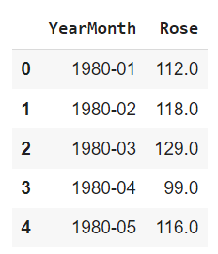
Fig 1. Sample of Rose Data

Data Types in the dataset before Data Modification:
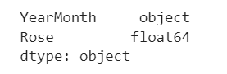
Fig 2. Datatype of Rose Data

Data Modification for easiness of Time Forecasting:

Since we have monthly data for years starting from 1980 to 1995 combined, let us draw a date range and incoporate as "TimeStamp" and drop "YearMonth" for ease.

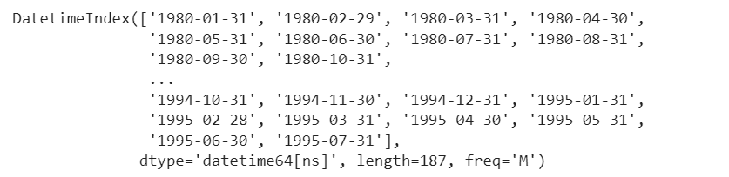
Fig 3. Date Index of Rose Data

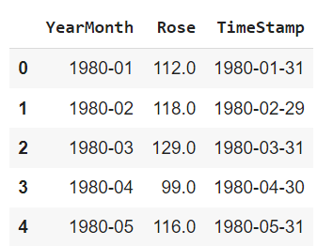
Fig 4. TimeStamp addition to Rose Data

After we have added the TimeStamp, the “YearMonth” is dropped, and TimeStamp is made the index. This would be the modified Dataset we use going forward.

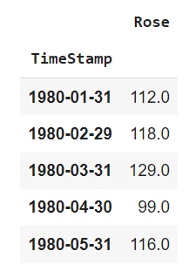
Fig 5. New Modified Rose Dataset

Basic details and Descriptive Statistics of Rose:

Fig 6. Length of Rose Dataset after modification

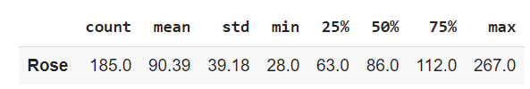
Fig 7. Descriptive Statistics of Rose Dataset after modification

Missing Values and Interpolation:

As we checked the dataset, there are 2 null or missing values. So, the values were interpolated. If this is not treated, it might cause a significant effect on the models we build.

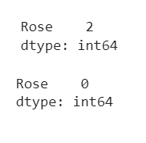
Fig 8. Null values before (above) and after (below) interpolation

Monthly Boxplot of Rose:

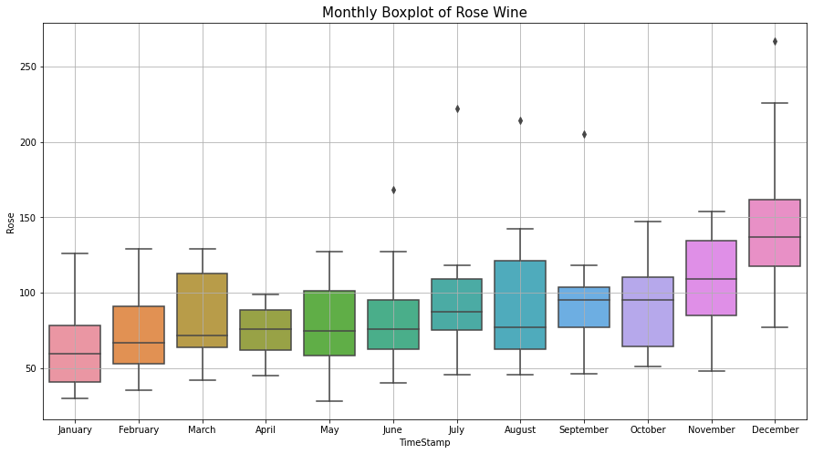
Fig 9. Monthly Boxplot of Rose

- The above plot shows a spike in the last quarter of October to December.

Monthly sales over years of Rose Wine:

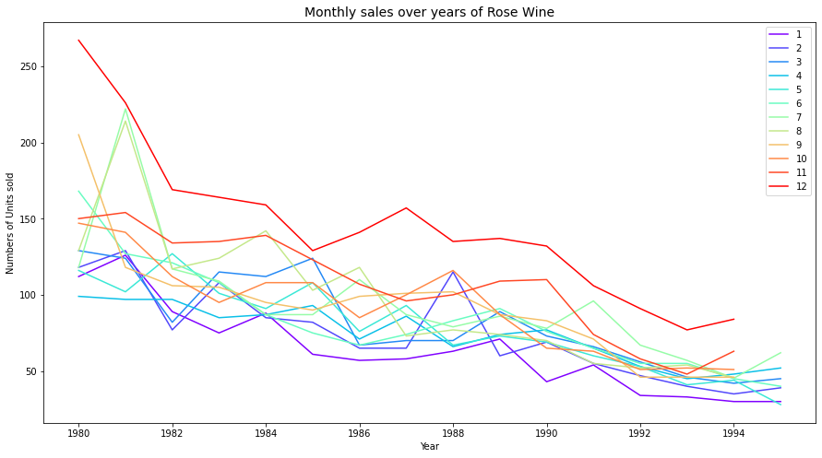
Fig 10. Monthly sales over years of Rose Wine

Visualization of Time Series in Rose:

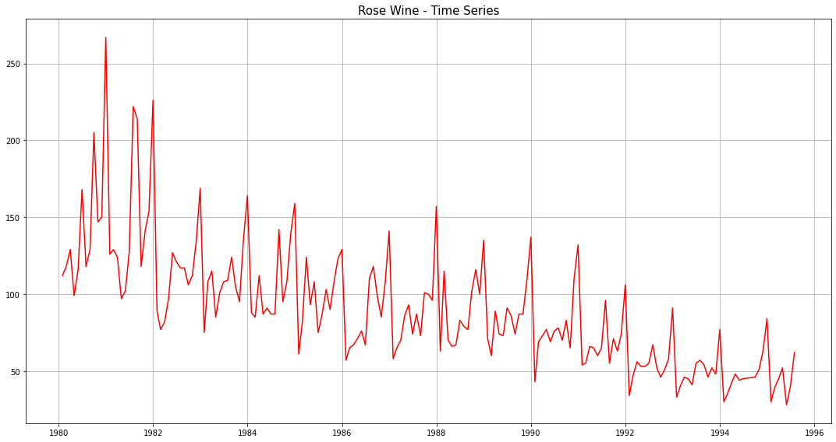
Fig 11. Visualization of Time Series in Rose

Decomposition and plots of different component:

Additive Decomposition of Rose Dataset:

Once we decompose the Rose dataset using additive model, we obtain the following parameters and their respective plots.

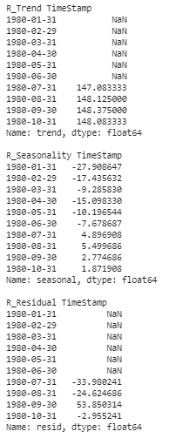
Fig 12. Trend, Seasonality and Residue of Rose
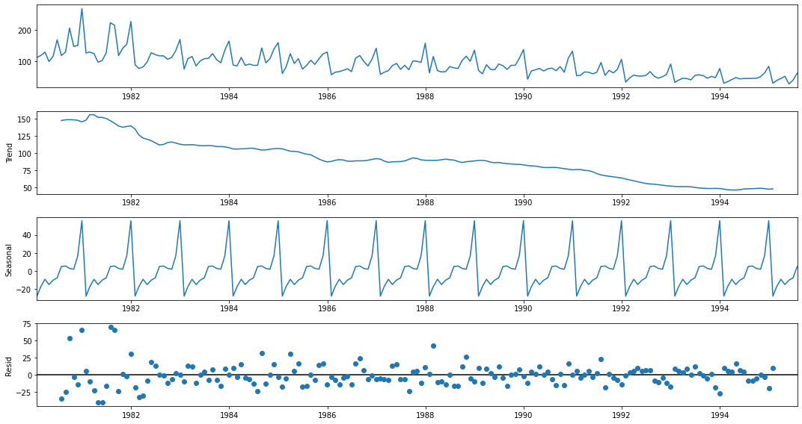
Fig 13. Trend, Seasonality and Residue plot for Rose

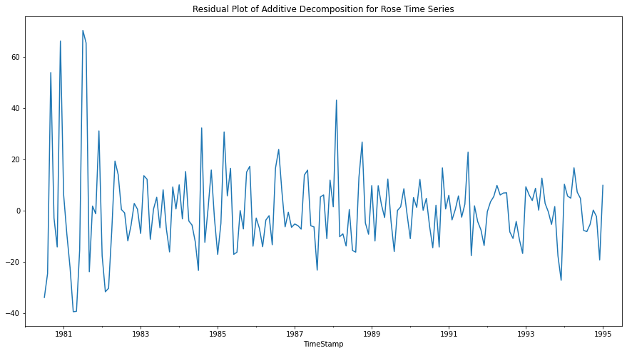
Fig 14. Residual Plot of Additive Decomposition for Rose Time Series

Multiplicative Decomposition of Rose Dataset:

Once we decompose the Rose dataset using additive model, we obtain the following parameters and their respective plots.

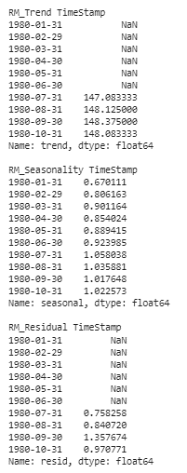
Fig 13. Trend, Seasonality and Residue of Rose (Multiplicative)

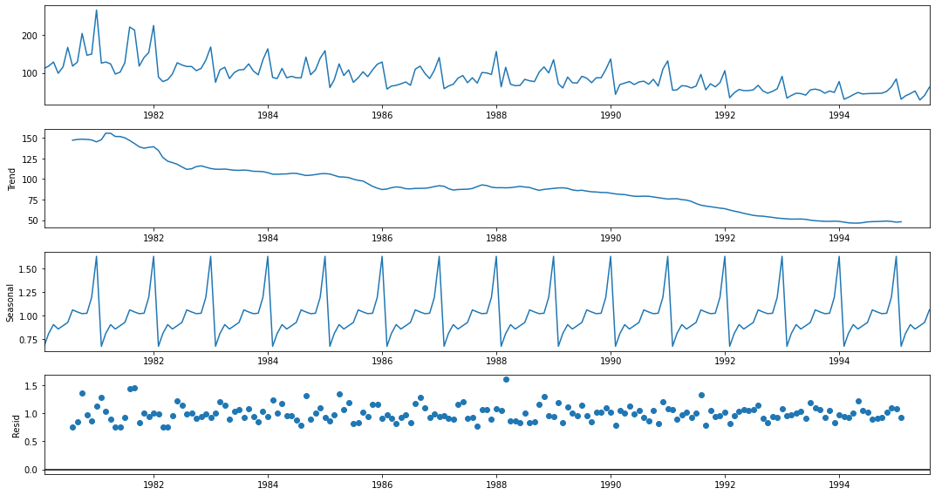
Fig 14. Trend, Seasonality and Residue plot for Rose (Multiplicative)

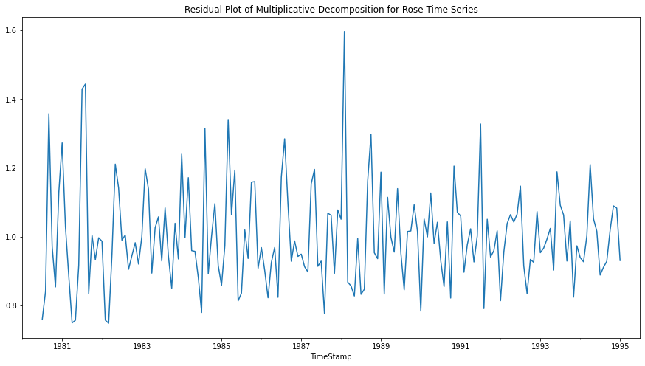
Fig 15. Residual Plot of Additive Decomposition for Rose Time Series (Multiplicative)

Conclusion:

Multiplicative Models
The seasonality increases or decreases over time. It is proportionate to the trend

Y_{t}= Trend * Seasonality * Residual

Here by just observing the Residual patterns of Additive and Multiplicative models of Rose, we can conclude that Rose follows multiplicative model.

Test and Train Split:

The whole Rose data was split into test and training dataset such that the test data starts in 1991.
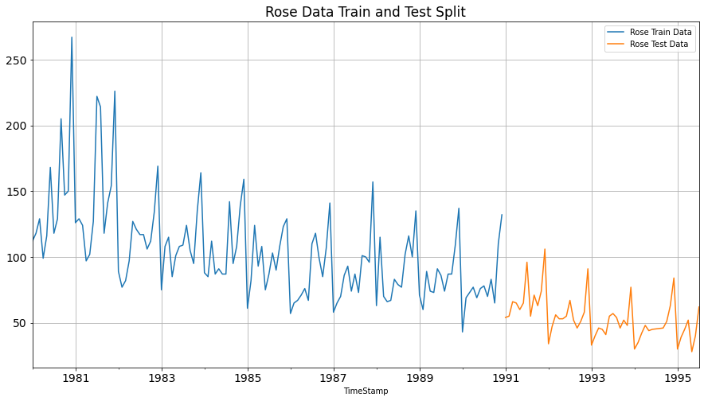
Fig 16. Test and training data for Rose

Various Models on the Rose Dataset to forecast the time series:

Model 1 – Linear Regression

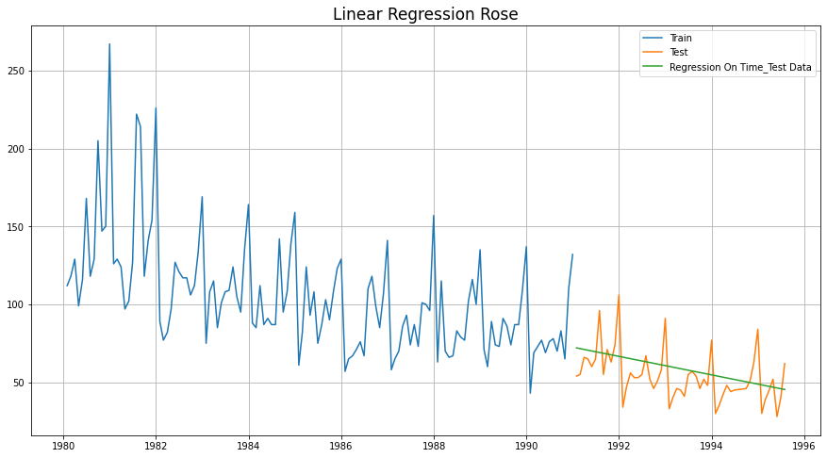
Fig 17. Linear Regression for Rose

Model 2 - Naive Bayes

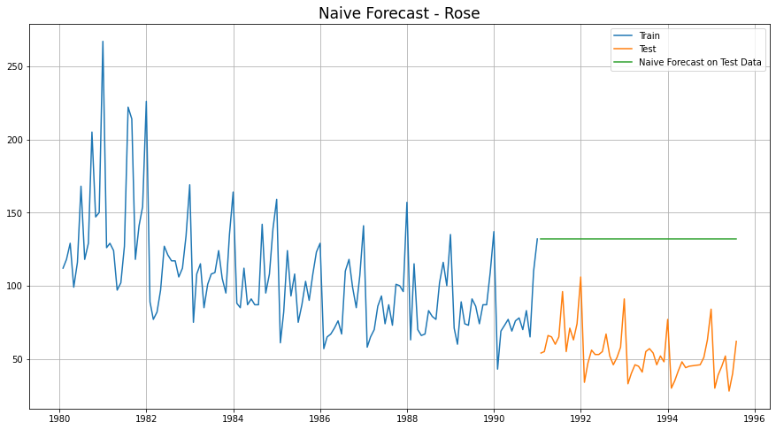
Fig 18. Naïve’s Approach for Rose

Model 3 - Simple Average

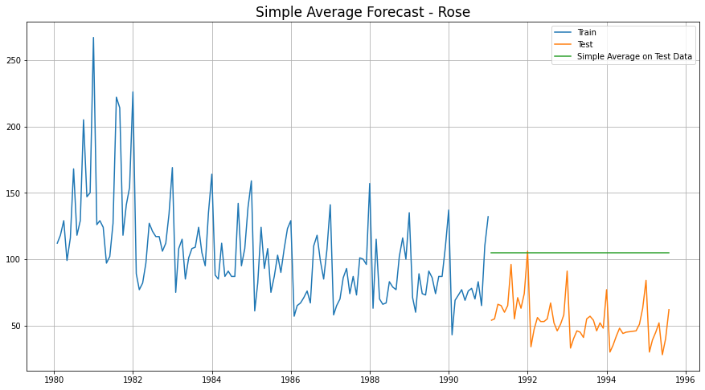
Fig 19. Simple Average Model for Rose

Model 4- Moving Average (Rose)

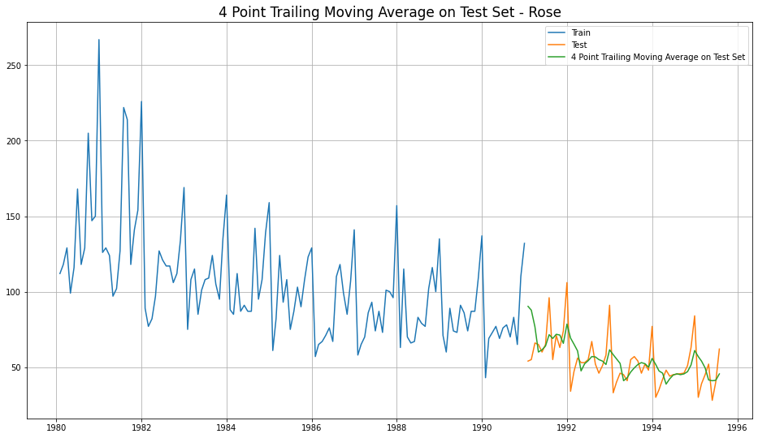
Fig 20. 4 Point Trailing Moving Average for Rose

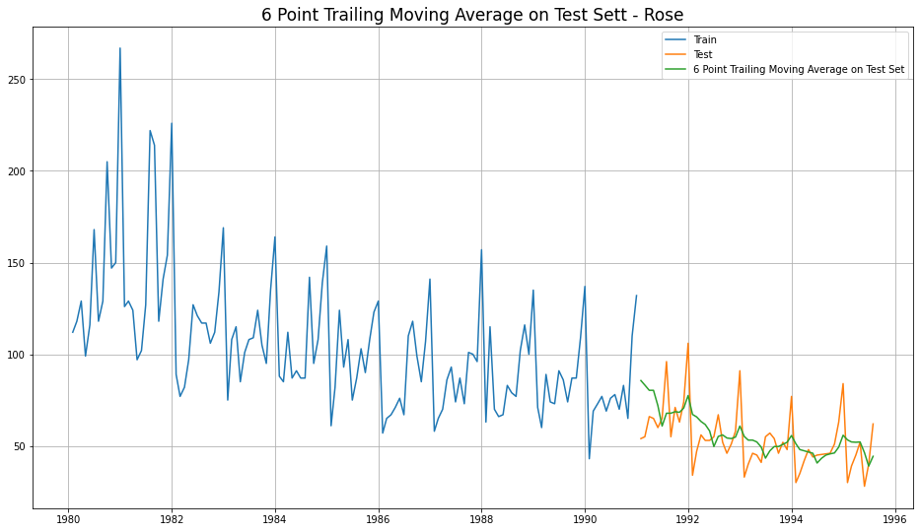
Fig 21. 6 Point Trailing Moving Average for Rose

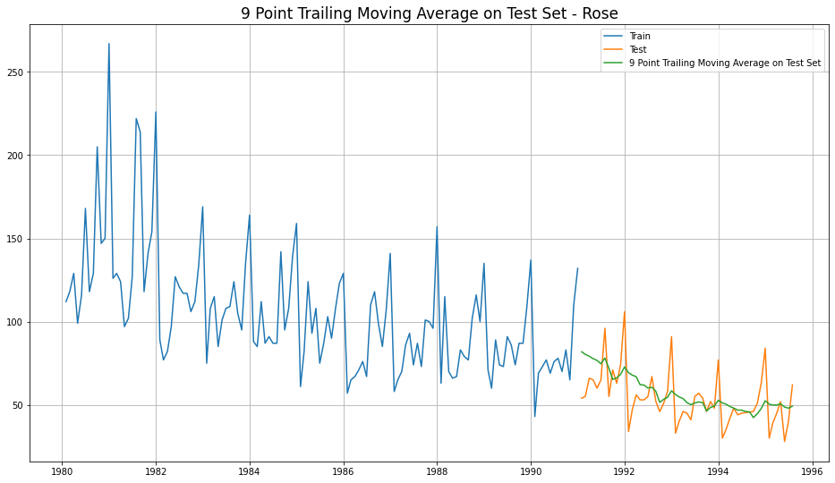
Fig 22. 9 Point Trailing Moving Average for Rose

Consolidated Moving Average Forecasts (Rose)

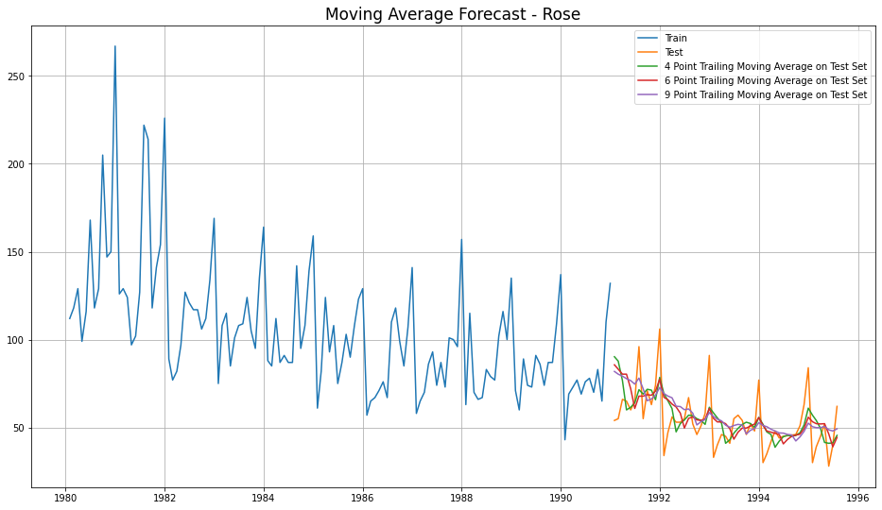
Fig 22. 4 Consolidated Trailing Moving Average for Rose

Let us see the best of all models built until now, before we go forward with Exponential Smoothing Models.
Model Name | Test RMSE Rose
Regression On Time | 15.268955
Naive Model | 79.718773
Simple Average Model | 53.46057
4point Trailing MovingAverage | 14.451403
6point Trailing MovingAverage | 14.566327
9point Trailing MovingAverage | 14.72763
Table 1 . Consolidated Scores of Regression, Naive, Simple Average & Moving Average

Till now, the best model built is 4point Trailing MovingAverage

Model 5 - Single Exponential Smoothing

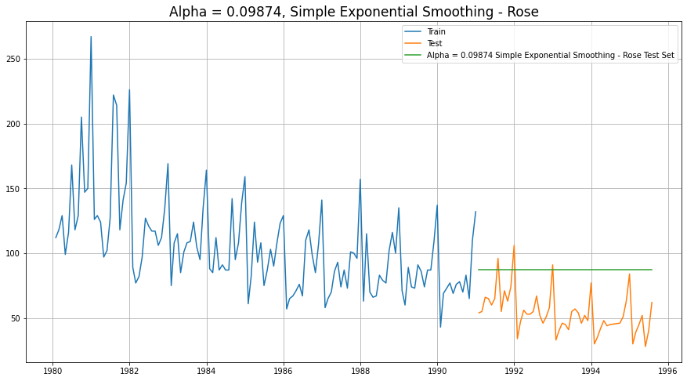
Fig 22. Single Exponential Smoothing

Model 6 - Double Exponential Smoothing

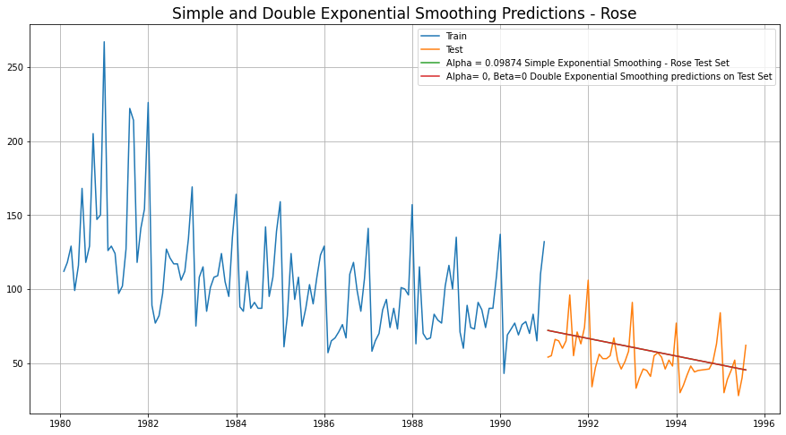
Fig 23. Single and Double Exponential Smoothing

Model 7 - Holt-Winter's Model (Exponential Smoothing) with additive errors

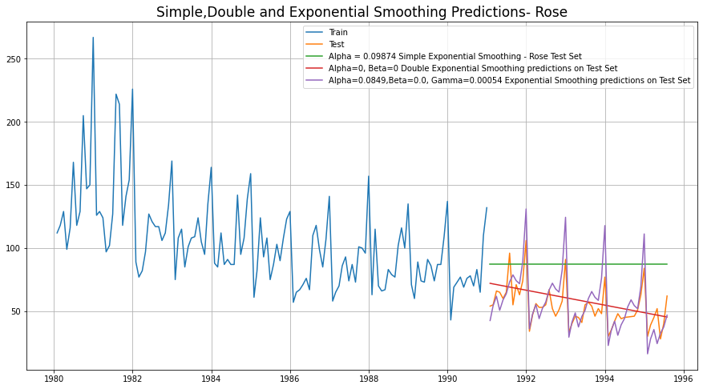
Fig 24. Simple, Double and Exponential Smoothing Predictions

Model 8 - Holt-Winter's Model (Exponential Smoothing) with multiplicative seasonality

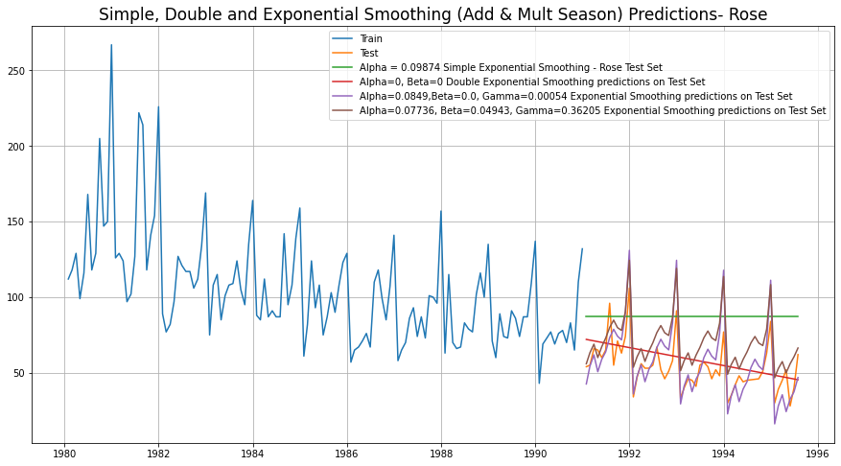
Fig 25. Simple, Double and Exponential Smoothing (Add & Mult.) Season

Conclusion at the end of Exponential Modelling, we see that the Exponential Smoothing with Additive Seasonality is the best model (least RMSE)

Model Name | Test RMSE Rose
Regression On Time | 15.268955
Naive Model | 79.718773
Simple Average Model | 53.46057
4point Trailing MovingAverage | 14.451403
6point Trailing MovingAverage | 14.566327
9point Trailing MovingAverage | 14.72763
Simple Exponential Smoothing | 36.796225
Double Exponential Smoothing | 15.270968
Exponential Smoothing (Additive Seasonality) | 14.24324
Exponential Smoothing (Multi Seasonality) | 19.11311

Table 2 -Consolidated Scores of Regression, Naive, Simple Average & Moving Average, Exponential Smoothing

Check for stationarity of the whole Time Series data

The Augmented Dickey-Fuller test is an unit root test which determines whether there is a unit root and subsequently whether the series is non-stationary.
The hypothesis in a simple form for the ADF test is:
- H0: The Time Series has a unit root and is thus non-stationary.
- H1:The Time Series does not have a unit root and is thus stationary
We would want the series to be stationary for building ARIMA models and thus we would want the p-value of this test to be less than the α (0.05) value.

Since the p-value is greater than 0.05, the Rose data set is non-stationary.

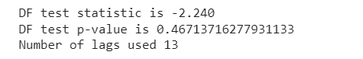
Fig 26. ADF test for Rose

To make the data stationary, lets difference and repeat the ADF for Rose
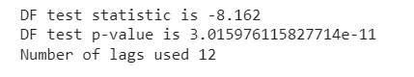
Fig 27. ADF test for Rose (diff)

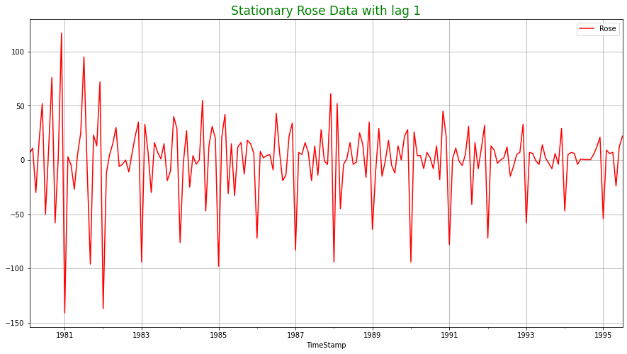

Model 9 – Automated ARIMA Model

- We create a grid of all possible combinations of (p, d, q)
- Range of p = Range of q = 0 to 3, Constant d = 1
- Few Examples of the grid -
    - Model: (0, 1, 0)
    - Model: (0, 1, 1)
    - Model: (0, 1, 2)
    - Model: (0, 1, 3)
    - Model: (1, 1, 0)
    - Model: (1, 1, 1)
    - Model: (1, 1, 2)
    - Model: (1, 1, 3)
    - Model: (2, 1, 0)
    - Model: (2, 1, 1)
    - Model: (2, 1, 2)
    - Model: (2, 1, 3)
    - Model: (3, 1, 0)
    - Model: (3, 1, 1)
    - Model: (3, 1, 2)
    - Model: (3, 1, 3)
- We fit ARIMA models to each of these combinations for both datasets
- We choose the combination with the least Akaike Information Criteria (AIC) - ARIMA (2, 1, 3)
- We fit ARIMA to this combination of (p, d, q) to the Train set and forecast on the Test set
- Finally, we check the accuracy of this model by checking RMSE of Test set

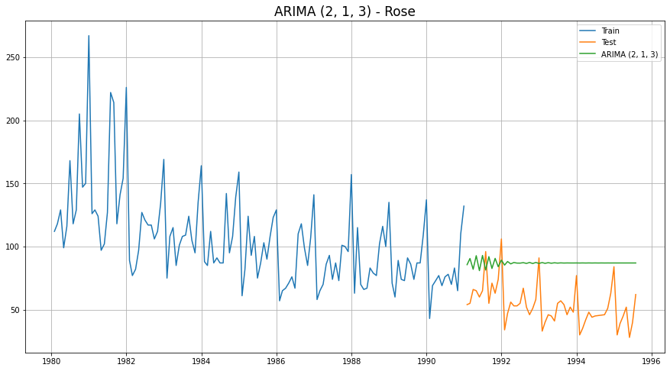
ARIMA (2, 1, 3) – Automated ARIMA

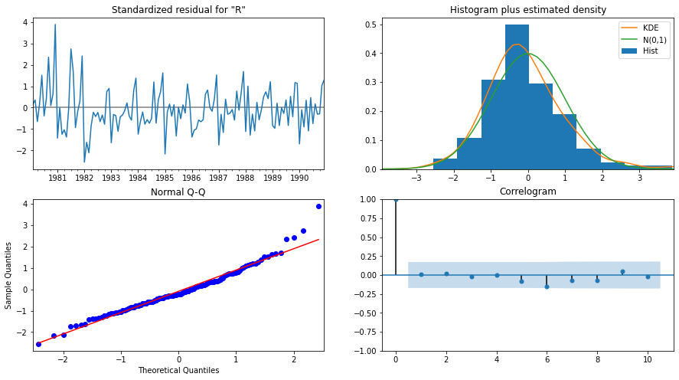
ARIMA (2, 1, 3) Diagnostic Plot – Rose

Model 10 – Manual ARIMA Model

- The Auto-Regressive parameter in an ARIMA model is 'p' which comes from the significant lag before which the PACF plot cuts-off to 2.
- The Moving-Average parameter in an ARIMA model is 'q' which comes from the significant lag before the ACF plot cuts-off to 2.
- By looking at the above plots, we will take the value of p and q to be 2 and 2 respectively.

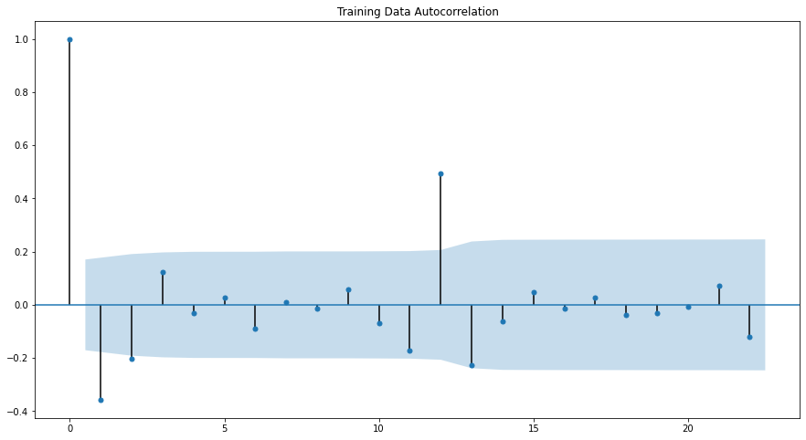
Training Data Autocorrelation

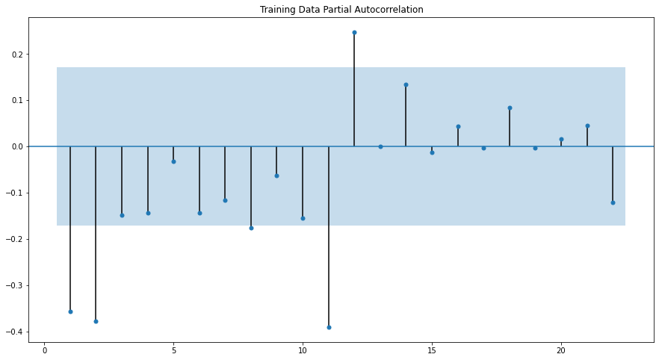
Training Data Partial Autocorrelation
ARIMA Manual - Rose - (2, 1, 2)
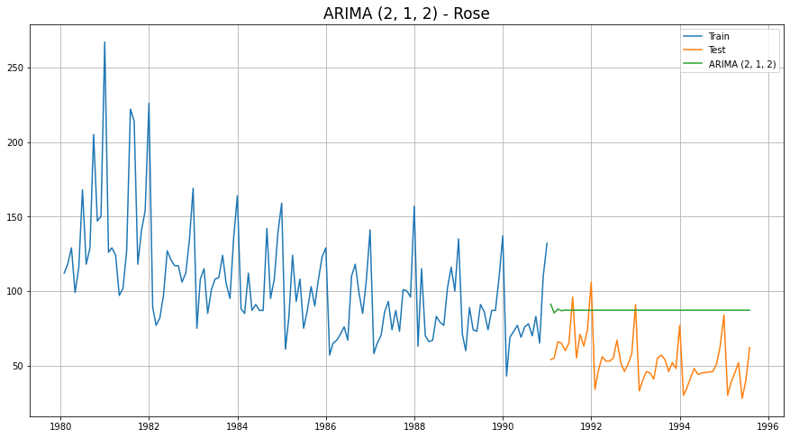
ARIMA (2, 1, 2) – Manual ARIMA
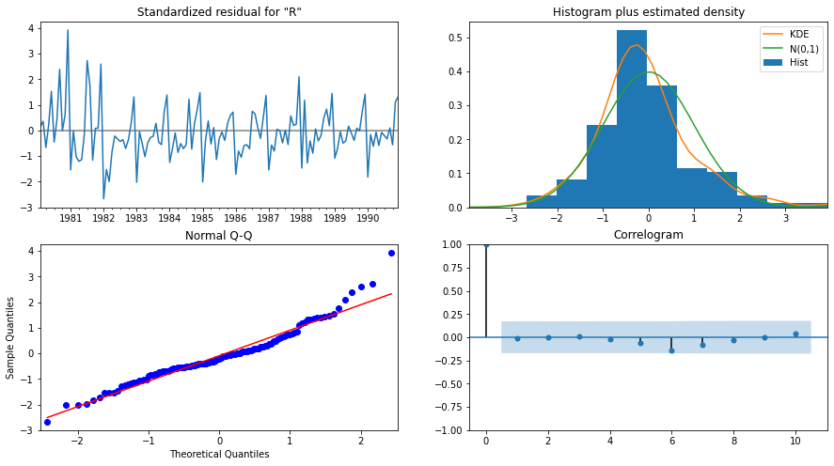
ARIMA (2, 1, 2) Diagnostic Plot - Rose

Model 11 – Automated SARIMA Model

- We create a grid of all possible combinations of (p, d, q) along with Seasonal
(P, D, Q) & Seasonality of 12 (for both datasets)
- Range of p = Range of q = 0 to 3, Constant d = 1
- Range of Seasonal P = Range of Seasonal Q = 0 to 3, Constant D = 1, Seasonality m = 12
- Few Examples of the grid (p, d, q) (P, D, Q, m) -
  - Model: (0, 1, 1)(0, 0, 1, 12)
  - Model: (0, 1, 2)(0, 0, 2, 12)
  - Model: (0, 1, 3)(0, 0, 3, 12)
  - Model: (1, 1, 0)(1, 0, 0, 12)
  - Model: (1, 1, 1)(1, 0, 1, 12)
  - Model: (1, 1, 2)(1, 0, 2, 12)
  - Model: (1, 1, 3)(1, 0, 3, 12)
  - Model: (2, 1, 0)(2, 0, 0, 12)
  - Model: (2, 1, 1)(2, 0, 1, 12)
  - Model: (2, 1, 2)(2, 0, 2, 12)
  - Model: (2, 1, 3)(2, 0, 3, 12)
  - Model: (3, 1, 0)(3, 0, 0, 12)
  - Model: (3, 1, 1)(3, 0, 1, 12)
  - Model: (3, 1, 2)(3, 0, 2, 12)
  - Model: (3, 1, 3)(3, 0, 3, 12)
- We fit SARIMA models to each of these combinations and select with least AIC
- We fit SARIMA to this best combination of (p, d, q) (P, D, Q, m) to the Train set and forecast on the Test set. Then, we check accuracy using RMSE on Test set
- For Rose, Best Combination with Least AIC is - (2, 1, 1) (1, 0, 3, 12)

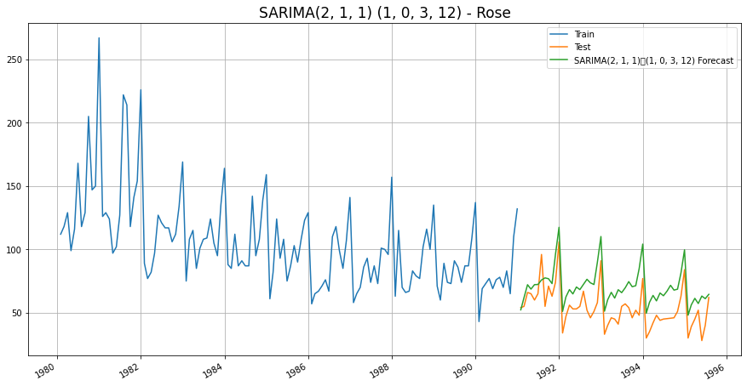
SARIMA (2, 1, 1) (1, 0, 3, 12) - Automated SARIMA

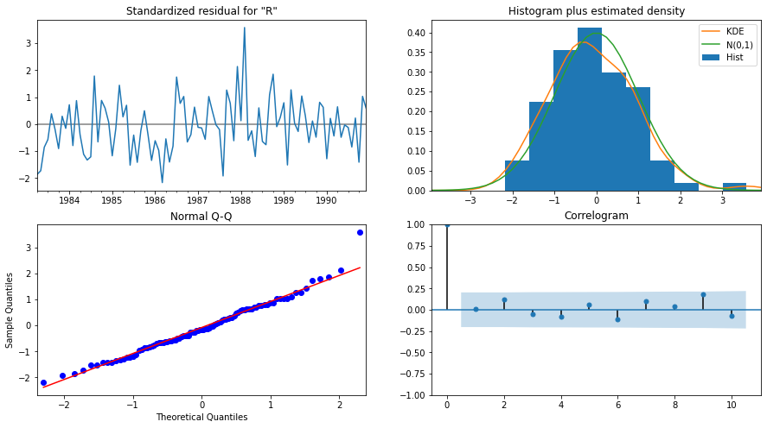
SARIMA (2, 1, 1) (1, 0, 3, 12) Diagnostic Plot – Rose

Model 12 – Manual SARIMA Model

We are going to take the seasonal period as 12 We are taking the p value to be 2 and the q value also to be 2 as the parameters same as the ARIMA model.

The Auto-Regressive parameter in a SARIMA model is 'P' which comes from the significant lag after which the PACF plot cuts-off to 2. The Moving-Average parameter in a SARIMA model is 'Q' which comes from the significant lag after which the ACF plot cuts-off to 3.

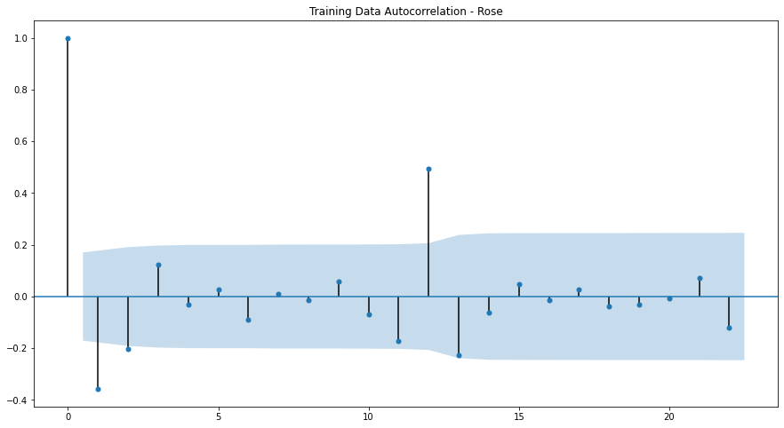
Training Data Autocorrelation
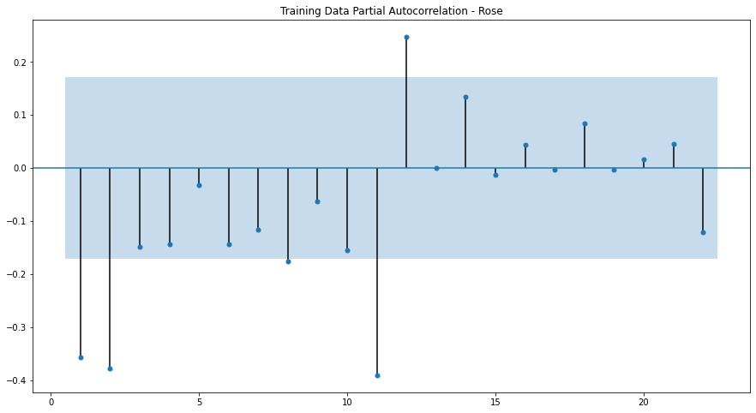
Training Data Partial Autocorrelation

SARIMA Manual - Rose - (2, 1, 2) (2, 1, 3, 12)
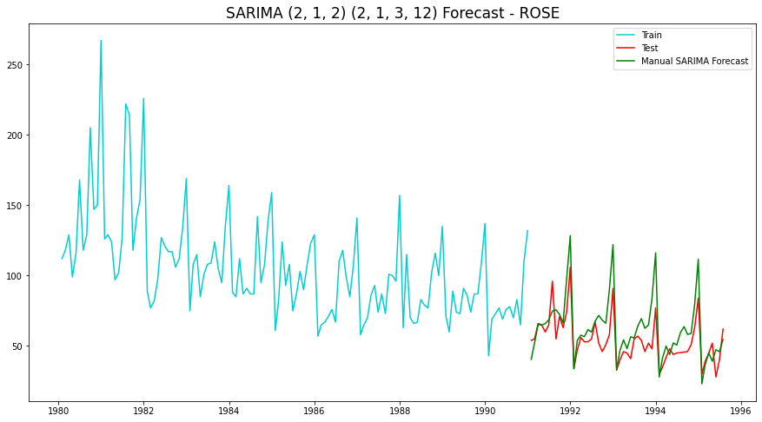
SARIMA (2, 1, 2) (2, 1, 3, 12) – Manual SARIMA

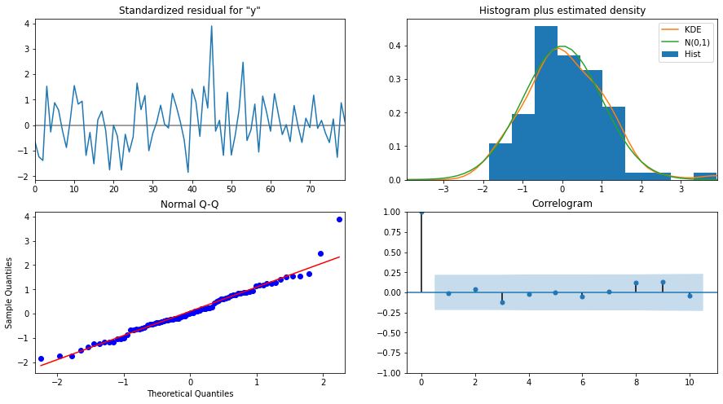

SARIMA (2, 1, 2) (2, 1, 3, 12) - Diagnostic Plot - Rose

Data Frame with all the RMSE values for models built:

Model Name | Test RMSE Rose
Regression On Time | 15.268955
Naive Model | 79.718773
Simple Average Model | 53.46057
4point Trailing MovingAverage | 14.451403
6point Trailing MovingAverage | 14.566327
9point Trailing MovingAverage | 14.72763
Simple Exponential Smoothing | 36.796225
Double Exponential Smoothing | 15.270968
Exponential Smoothing (Additive Seasonality) | 14.24324
Exponential Smoothing (Multi Seasonality) | 19.11311
ARIMA (2, 1, 3) | 36.81575
ARIMA (2, 1, 2) | 36.871197
SARIMA (2, 1, 1) (1, 0, 3, 12) | 19.003214
SARIMA (2, 1, 2) (2, 1, 3, 12) | 14.799237

Conclusion:

As we can see the above table, the lease RMSE out of all models built is Exponential Smoothing (Additive Seasonality).

Let us now build the model on full data and predict the upcoming 12 months.

Final Model – Exponential Smoothing with additive seasonality

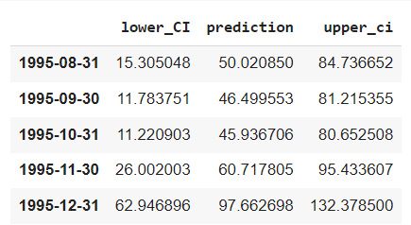

Final Model Forecast: Exponential Smoothing (Additive Seasonality - Rose

Rose Wine Sales - Suggestions :
- First and foremost, the holiday season is rapidly approaching, with sales expected to increase and peak in December. As a result, the company should stock up. However, the long-term decline in Rose Wine sales should be investigated with more data crunching.
- The company can rebrand its Rose variant as well as hire a new Wine-master.
- The company should capitalise on the impending spike from August to October by launching aggressive offers and advertising campaigns.
- This will entice first-time wine drinkers and fence sitters (who do not have specific loyalties to any particular brand).
- However, if there is no significant increase in sales by December, the company has two options: invest in R&D or consider discontinuing this variant and coming up with something completely new.

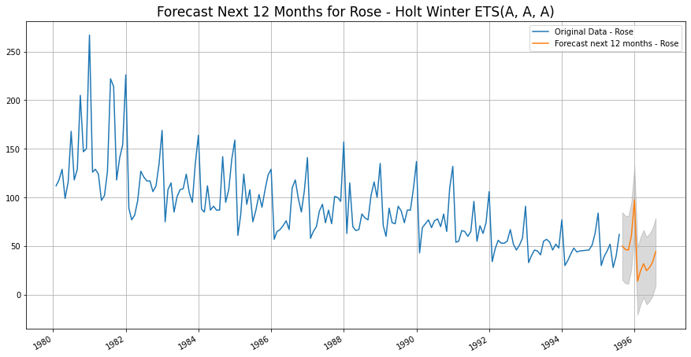
Final Model: Exponential Smoothing (Additive Seasonality - Rose

Sparkling Dataset

Exploratory Data Analysis

Sample of the dataset:
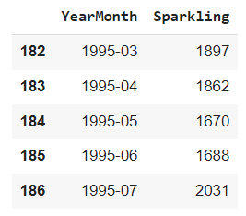
Sample of Sparkling Data

Data Types in the dataset before Data Modification:
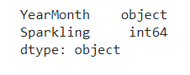
Datatype of Sparkling Data

Data Modification for easiness of Time Forecasting:

Since we have monthly data for years starting from 1980 to 1995 combined, let us draw a date range and incorporate as "TimeStamp" and drop "YearMonth" for ease.

Date Index of Sparkling Data

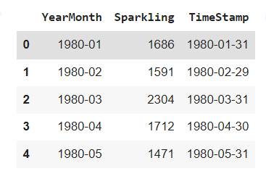
TimeStamp addition to Sparkling Data

After we have added the TimeStamp, the “YearMonth” is dropped, and TimeStamp is made the index. This would be the modified Dataset we use going forward.

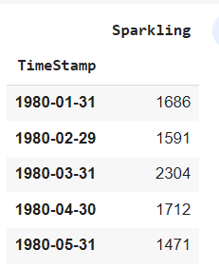
New Modified Sparkling Dataset

Basic details and Descriptive Statistics of Rose:

Length of Sparkling Dataset after modification

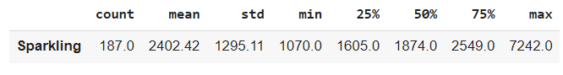
Descriptive Statistics of Sparkling Dataset after modification

Missing Values and Interpolation:

As we checked the dataset, there are no null values. Let us go forward with a couple of analysis before building the models


No Null Values

Monthly Boxplot of Sparkling:

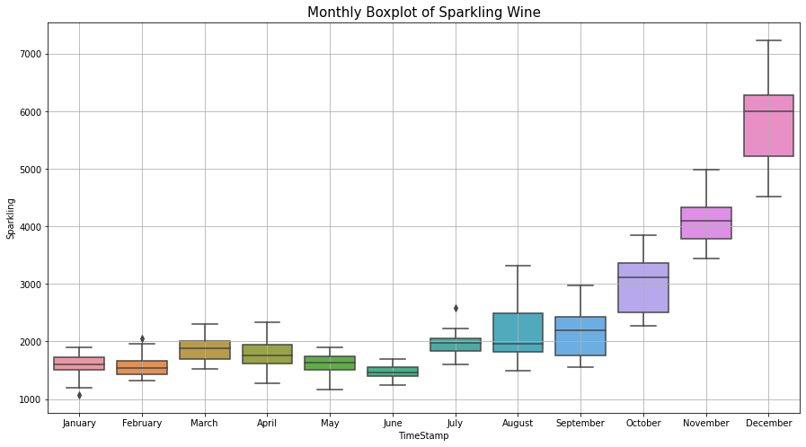
Monthly Boxplot of Sparkling

- Sales of both - Rose and Sparkling, show a spike in the last quarter of Oct to Dec
- Spike is much more accentuated in Sparkling sales
- This spike may be due to the Holiday season starting in Oct

Monthly sales over years of Sparkling Wine:

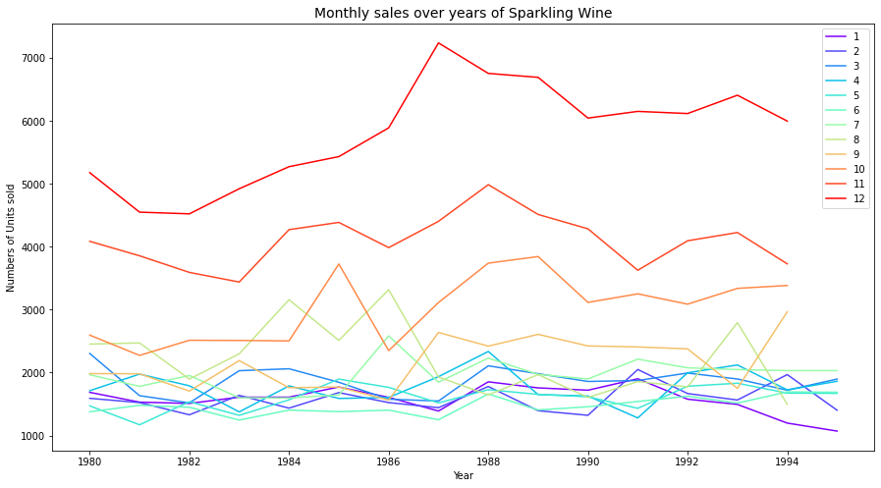
Monthly sales over years of Sparkling Wine

Visualization of Time Series in Sparkling:

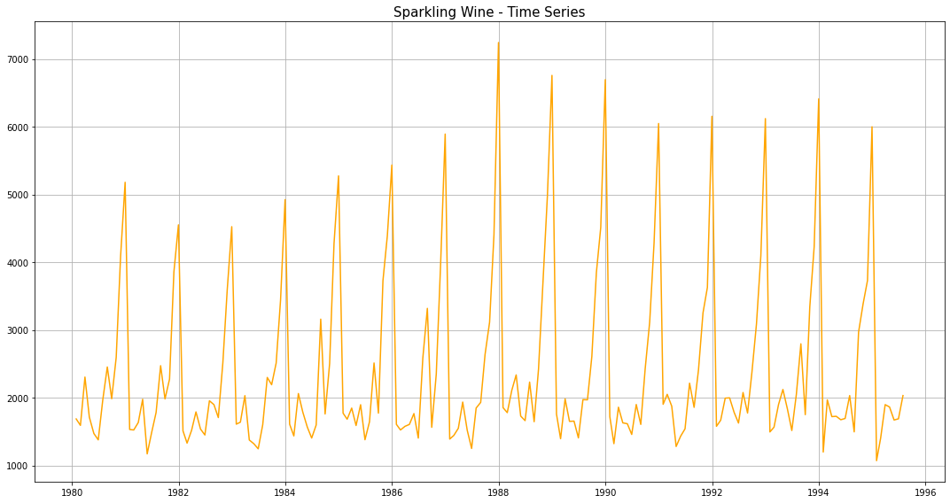
Visualization of Time Series in Sparkling

Decomposition and plots of different component:

Additive Decomposition of Sparkling Dataset:

Once we decompose the Rose dataset using additive model, we obtain the following parameters and their respective plots.

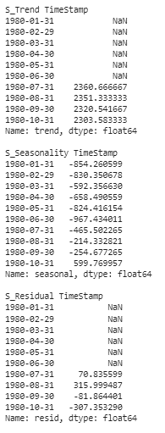
Trend, Seasonality and Residue of Sparkling
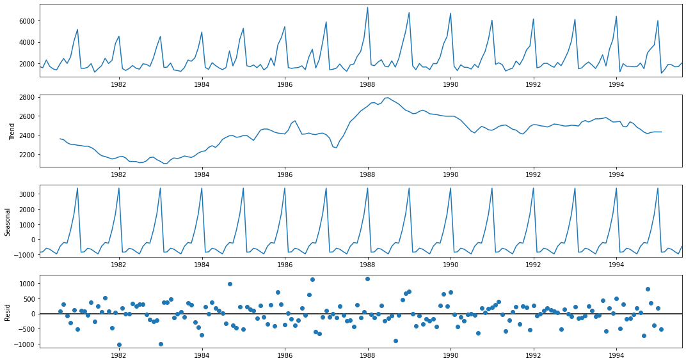
Trend, Seasonality and Residue plot for Sparkling

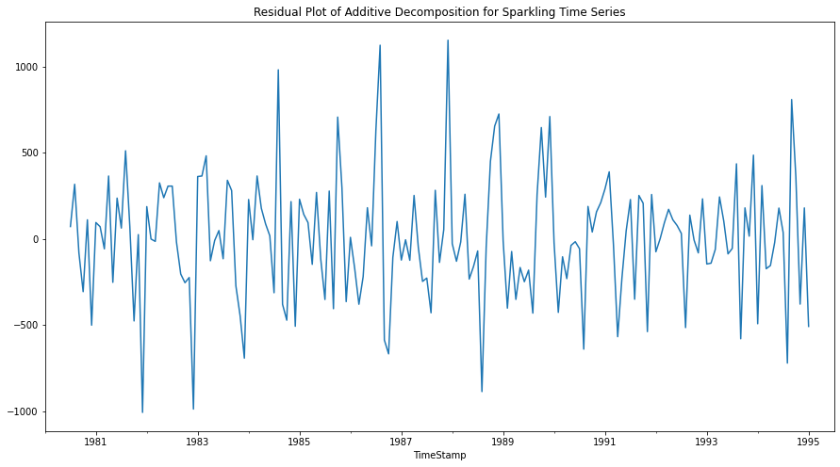
Residual Plot of Additive Decomposition for Sparkling Time Series

Multiplicative Decomposition of Sparkling Dataset:

Once we decompose the Rose dataset using additive model, we obtain the following parameters and their respective plots.

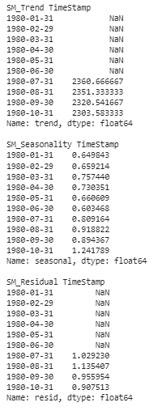
Trend, Seasonality and Residue of Sparkling (Multiplicative)

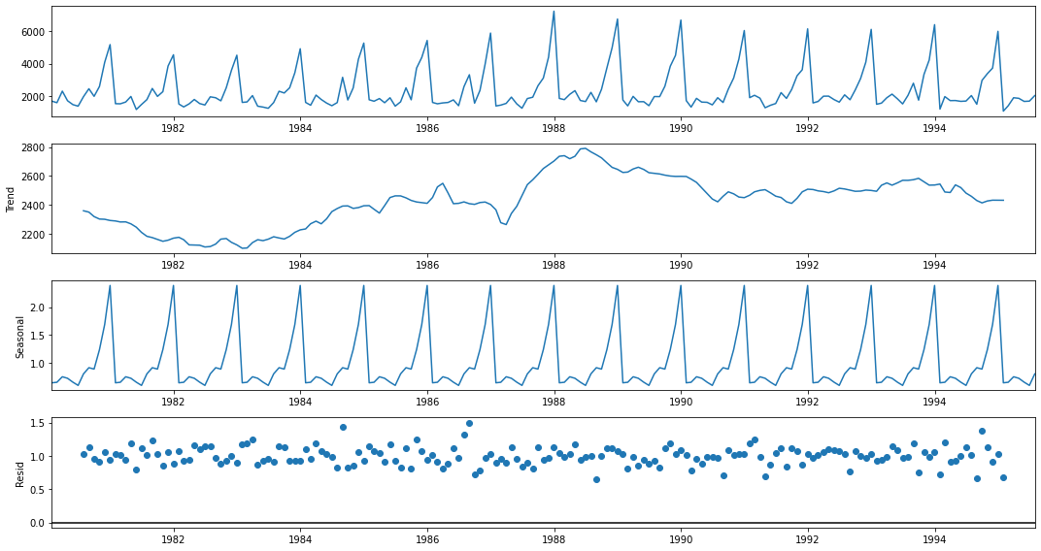
Trend, Seasonality and Residue plot for Sparkling (Multiplicative)

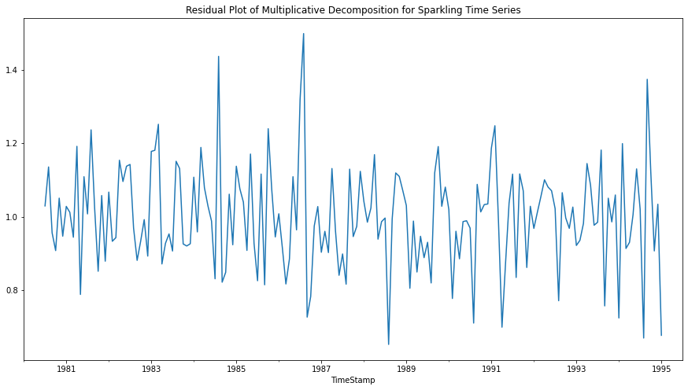
Residual Plot of Additive Decomposition for Sparkling Time Series (Multiplicative)

Conclusion:

Additive Model-
The seasonality is relatively constant over time

Y_{t}= Trend * Seasonality * Residual

Here by just observing the Residual patterns of Additive and Multiplicative models of Sparkling, we can conclude that Sparkling follows additive model.

Test and Train Split:

The whole Rose data was split into test and training dataset such that the test data starts in 1991.
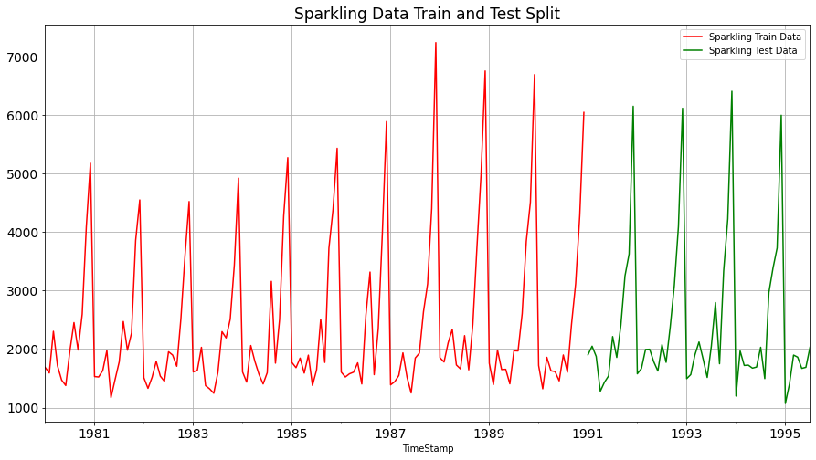
Fig 16. Test and training data for Sparkling

Various Models on the Sparkling Dataset to forecast the time series:

Model 1 – Linear Regression

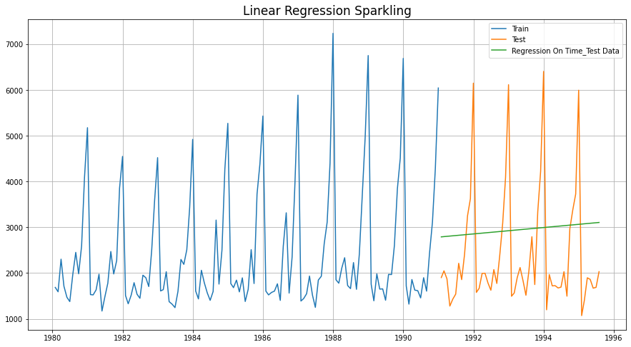
Fig 17. Linear Regression for Sparkling

Model 2 - Naive Bayes

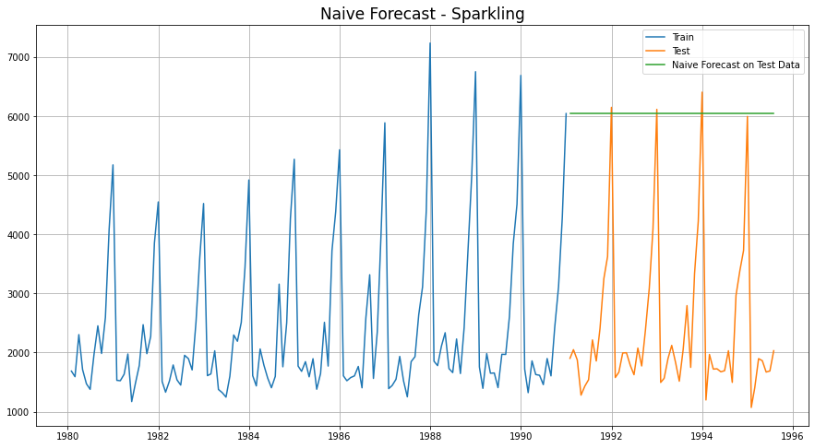
Fig 18. Naïve’s Approach for Sparkling

Model 3 - Simple Average

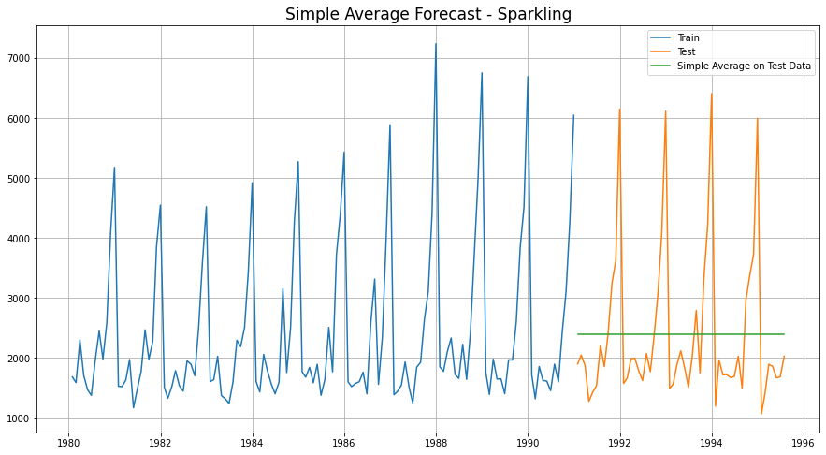
Fig 19. Simple Average Model for Sparkling

Model 4- Moving Average (Sparkling)

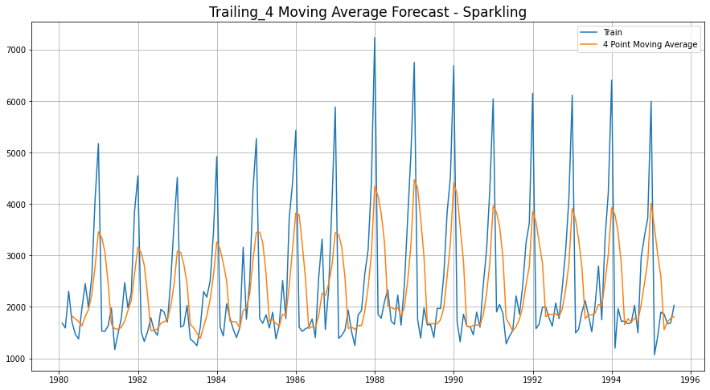
4 Point Trailing Moving Average for Sparkling

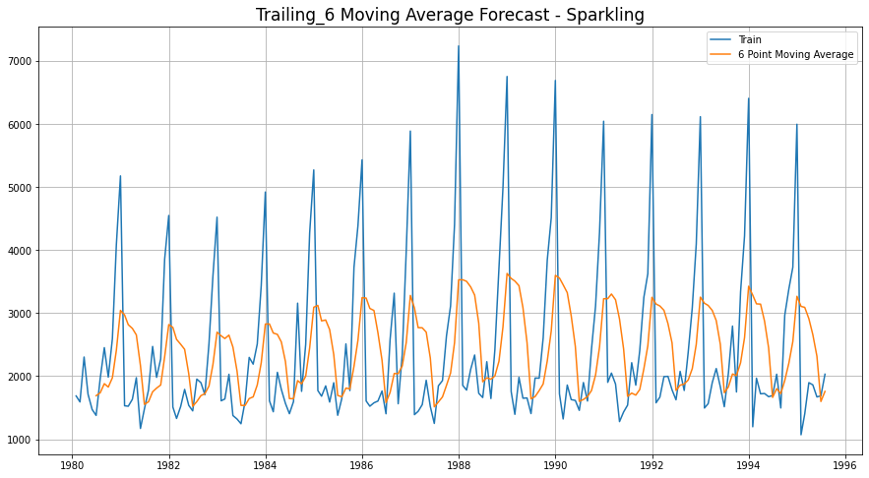
6 Point Trailing Moving Average for Sparkling

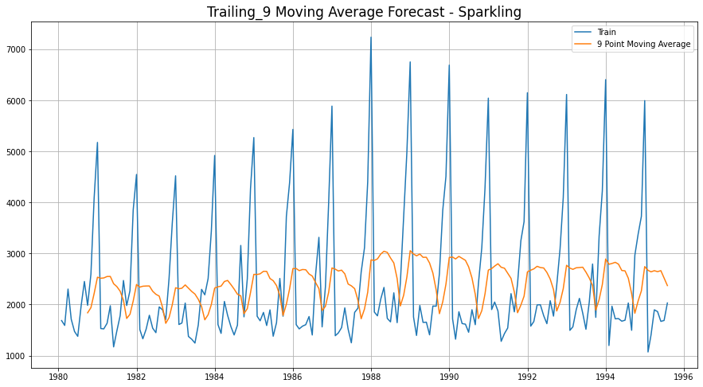
9 Point Trailing Moving Average for Sparkling

Consolidated Moving Average Forecasts (Sparkling)

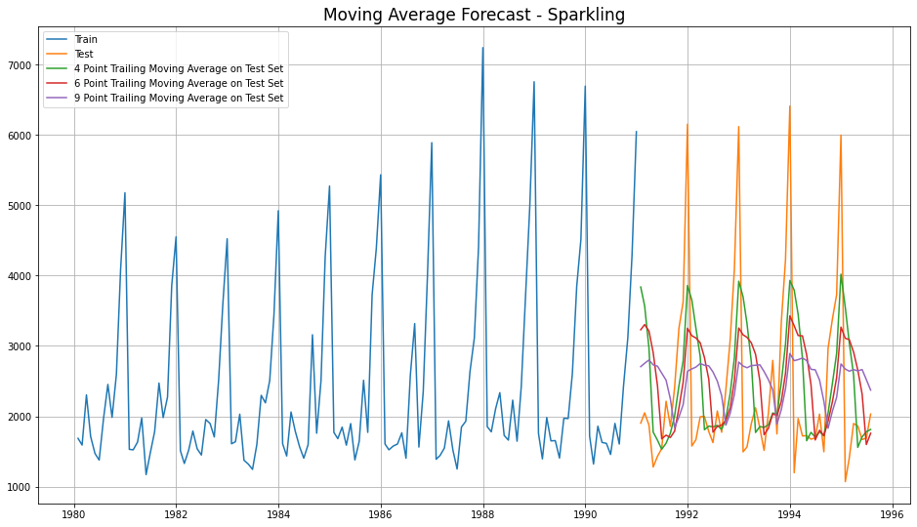
4 Consolidated Trailing Moving Average for Sparkling

Let us see the best of all models built until now, before we go forward with Exponential Smoothing Models.
Model Name | Test RMSE Sparkling
Regression On Time | 1389.135175
Naive Model | 3864.279352
Simple Average Model | 1275.081804
4point Trailing MovingAverage | 1156.589694
6point Trailing MovingAverage | 1283.927428
9point Trailing MovingAverage | 1346.278315
Consolidated Scores of Regression, Naive, Simple Average & Moving Average

Till now, the best model built is 4point Trailing MovingAverage

Model 5 - Single Exponential Smoothing

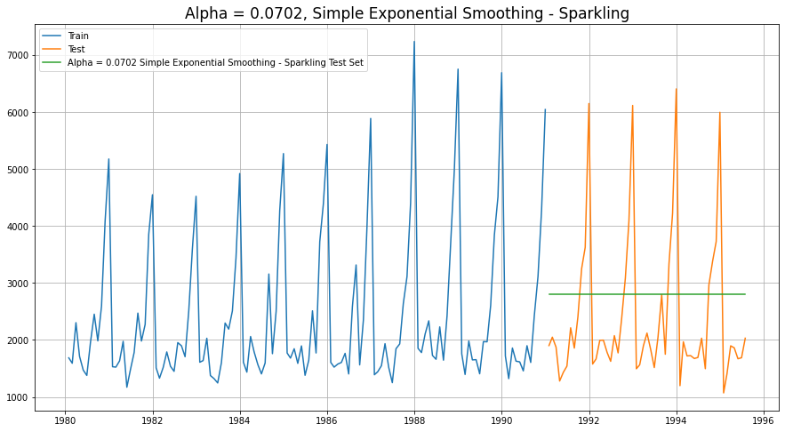
Single Exponential Smoothing

Model 6 - Double Exponential Smoothing

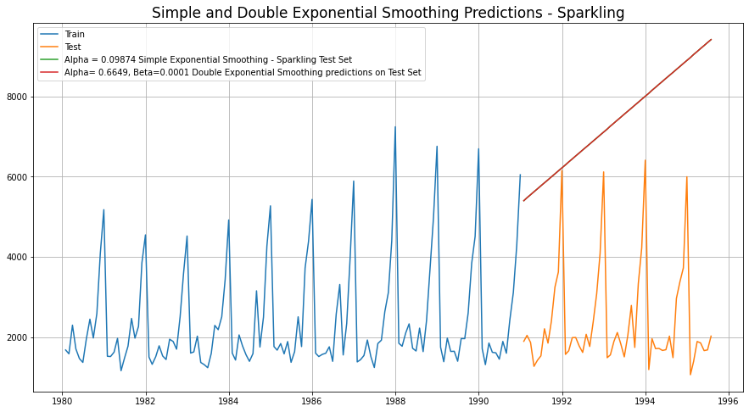
Single and Double Exponential Smoothing

Model 7 - Holt-Winter's Model (Exponential Smoothing) with additive errors

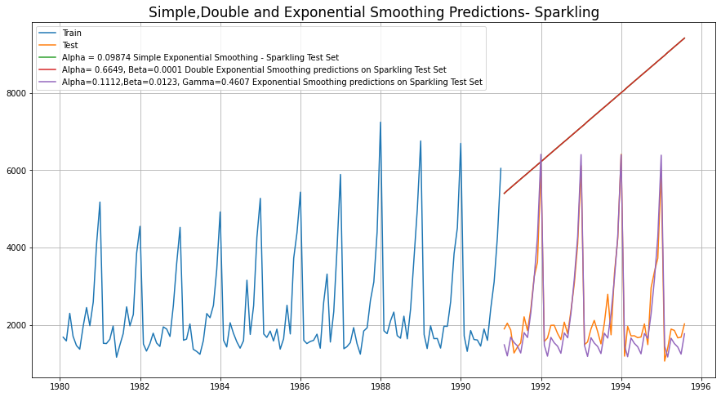
Simple, Double and Exponential Smoothing Predictions

Model 8 - Holt-Winter's Model (Exponential Smoothing) with multiplicative seasonality

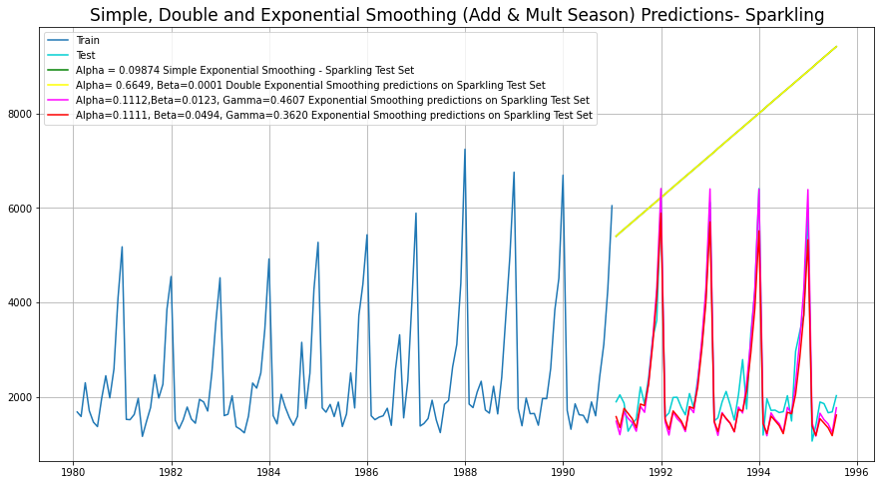
Simple, Double and Exponential Smoothing (Add & Mult.) Season

Conclusion at the end of Exponential Modelling, we see that the Exponential Smoothing with Additive Seasonality is the best model (least RMSE)

Model Name | Test RMSE Rose
Regression On Time | 1389.135175
Naive Model | 3864.279352
Simple Average Model | 1275.081804
4point Trailing MovingAverage | 1156.589694
6point Trailing MovingAverage | 1283.927428
9point Trailing MovingAverage | 1346.278315
Simple Exponential Smoothing | 1338.004623
Double Exponential Smoothing | 5291.879833
Exponential Smoothing (Additive Seasonality) | 378.626241
Exponential Smoothing (Multi Seasonality) | 403.706228

Consolidated Scores of Regression, Naive, Simple Average & Moving Average, Exponential Smoothing

Check for stationarity of the whole Time Series data

The Augmented Dickey-Fuller test is an unit root test which determines whether there is a unit root and subsequently whether the series is non-stationary.
The hypothesis in a simple form for the ADF test is:
- H0: The Time Series has a unit root and is thus non-stationary.
- H1:The Time Series does not have a unit root and is thus stationary
We would want the series to be stationary for building ARIMA models and thus we would want the p-value of this test to be less than the α (0.05) value.

Since the p-value is greater than 0.05, the Rose data set is non-stationary.

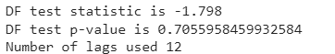
ADF test for Sparkling

To make the data stationary, lets difference and repeat the ADF for Rose
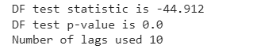
ADF test for Sparkling (diff)

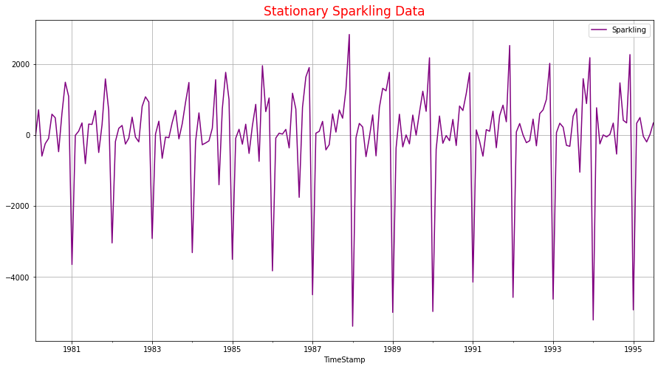

Model 9 – Automated ARIMA Model

- We create a grid of all possible combinations of (p, d, q)
- Range of p = Range of q = 0 to 3, Constant d = 1
- Few Examples of the grid -
    - Model: (0, 1, 0)
    - Model: (0, 1, 1)
    - Model: (0, 1, 2)
    - Model: (0, 1, 3)
    - Model: (1, 1, 0)
    - Model: (1, 1, 1)
    - Model: (1, 1, 2)
    - Model: (1, 1, 3)
    - Model: (2, 1, 0)
    - Model: (2, 1, 1)
    - Model: (2, 1, 2)
    - Model: (2, 1, 3)
    - Model: (3, 1, 0)
    - Model: (3, 1, 1)
    - Model: (3, 1, 2)
    - Model: (3, 1, 3)
- We fit ARIMA models to each of these combinations for both datasets
- We choose the combination with the least Akaike Information Criteria (AIC) - ARIMA (2, 1, 2)
- We fit ARIMA to this combination of (p, d, q) to the Train set and forecast on the Test set
- Finally, we check the accuracy of this model by checking RMSE of Test set

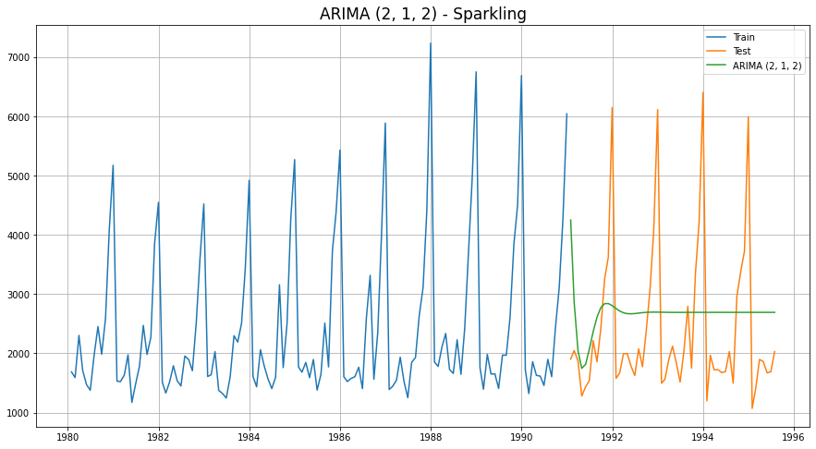
ARIMA (2, 1, 2) – Automated ARIMA

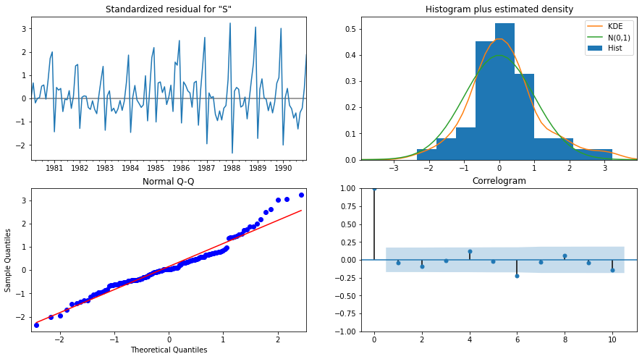
ARIMA (2, 1, 2) Diagnostic Plot – Sparkling

Model 10 – Manual ARIMA Model

- The Auto-Regressive parameter in an ARIMA model is 'p' which comes from the significant lag before which the PACF plot cuts-off to 0.
- The Moving-Average parameter in an ARIMA model is 'q' which comes from the significant lag before the ACF plot cuts-off to 0.
- By looking at the above plots, we will take the value of p and q to be 0 and 0 respectively.

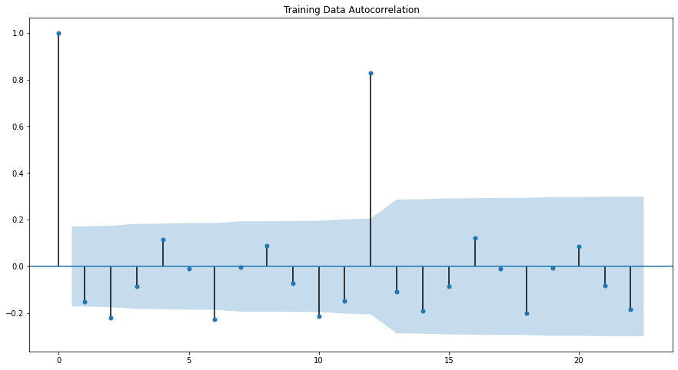
Training Data Autocorrelation

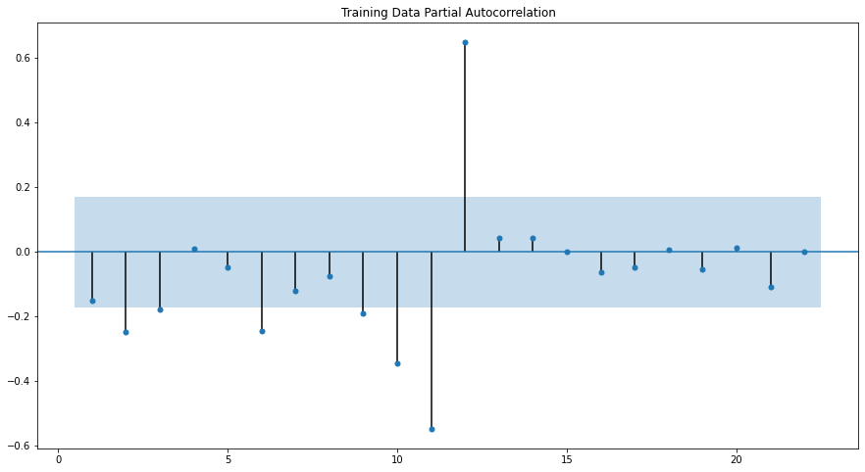
Training Data Partial Autocorrelation
ARIMA Manual - Rose - (0,1,0)
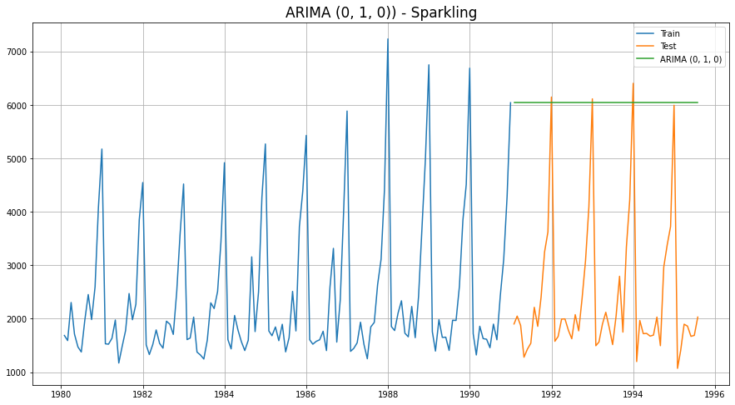
ARIMA (0,1,0) – Manual ARIMA
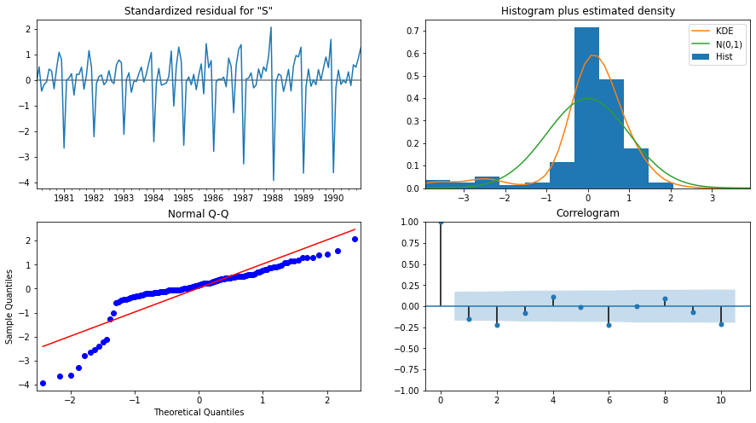
ARIMA (0,1,0) Diagnostic Plot - Rose

Model 11 – Automated SARIMA Model

- We create a grid of all possible combinations of (p, d, q) along with Seasonal
(P, D, Q) & Seasonality of 12 (for both datasets)
- Range of p = Range of q = 0 to 3, Constant d = 1
- Range of Seasonal P = Range of Seasonal Q = 0 to 3, Constant D = 1, Seasonality m = 12
- Few Examples of the grid (p, d, q) (P, D, Q, m) -
  - Model: (0, 1, 1)(0, 0, 1, 12)
  - Model: (0, 1, 2)(0, 0, 2, 12)
  - Model: (0, 1, 3)(0, 0, 3, 12)
  - Model: (1, 1, 0)(1, 0, 0, 12)
  - Model: (1, 1, 1)(1, 0, 1, 12)
  - Model: (1, 1, 2)(1, 0, 2, 12)
  - Model: (1, 1, 3)(1, 0, 3, 12)
  - Model: (2, 1, 0)(2, 0, 0, 12)
  - Model: (2, 1, 1)(2, 0, 1, 12)
  - Model: (2, 1, 2)(2, 0, 2, 12)
  - Model: (2, 1, 3)(2, 0, 3, 12)
  - Model: (3, 1, 0)(3, 0, 0, 12)
  - Model: (3, 1, 1)(3, 0, 1, 12)
  - Model: (3, 1, 2)(3, 0, 2, 12)
  - Model: (3, 1, 3)(3, 0, 3, 12)
- We fit SARIMA models to each of these combinations and select with least AIC
- We fit SARIMA to this best combination of (p, d, q) (P, D, Q, m) to the Train set and forecast on the Test set. Then, we check accuracy using RMSE on Test set
- For Rose, Best Combination with Least AIC is - (3, 1, 3) (0, 0, 3, 12)

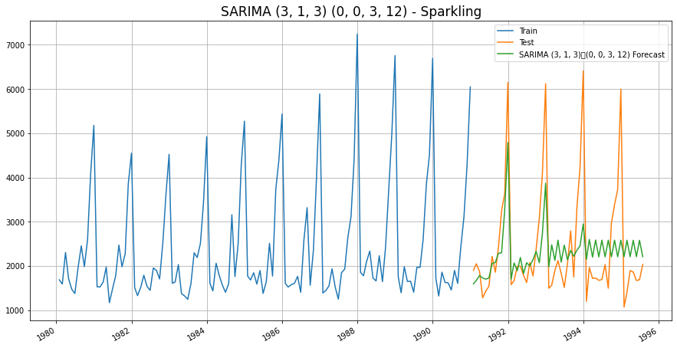
SARIMA (3, 1, 3)(0, 0, 3, 12)- Automated SARIMA

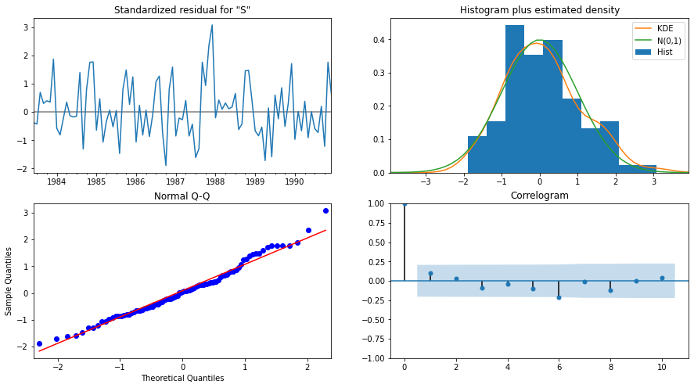
SARIMA (3, 1, 3)(0, 0, 3, 12)Diagnostic Plot – Rose

Model 12 – Manual SARIMA Model

We are going to take the seasonal period as 12 We are taking the p value to be 2 and the q value also to be 0 as the parameters same as the ARIMA model.

The Auto-Regressive parameter in a SARIMA model is 'P' which comes from the significant lag after which the PACF plot cuts-off to 4. The Moving-Average parameter in a SARIMA model is 'Q' which comes from the significant lag after which the ACF plot cuts-off to 2.
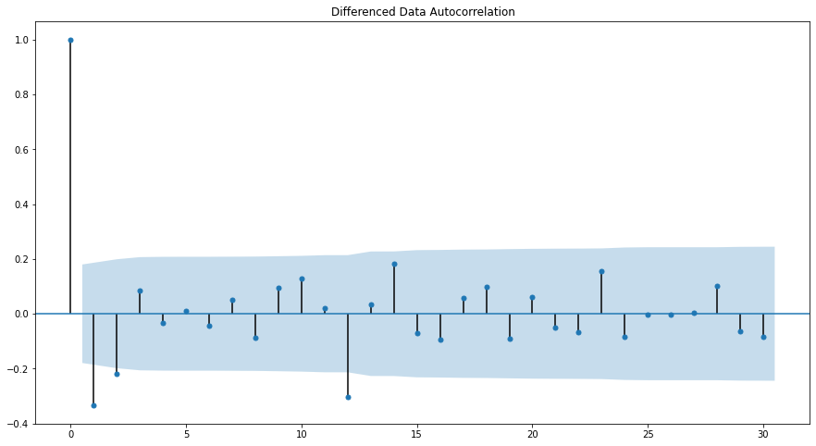
Training Data Autocorrelation
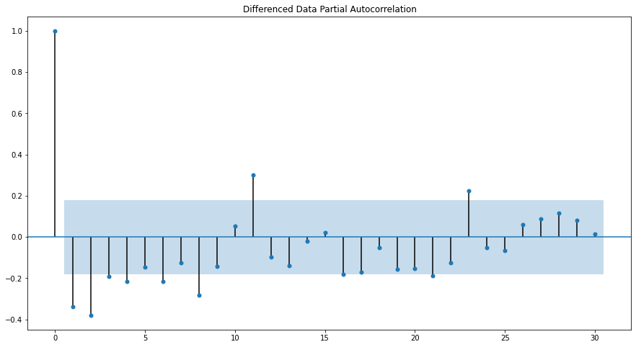
Training Data Partial Autocorrelation

SARIMA Manual - Sparkling - (0, 1, 0) (4, 1, 2, 12)
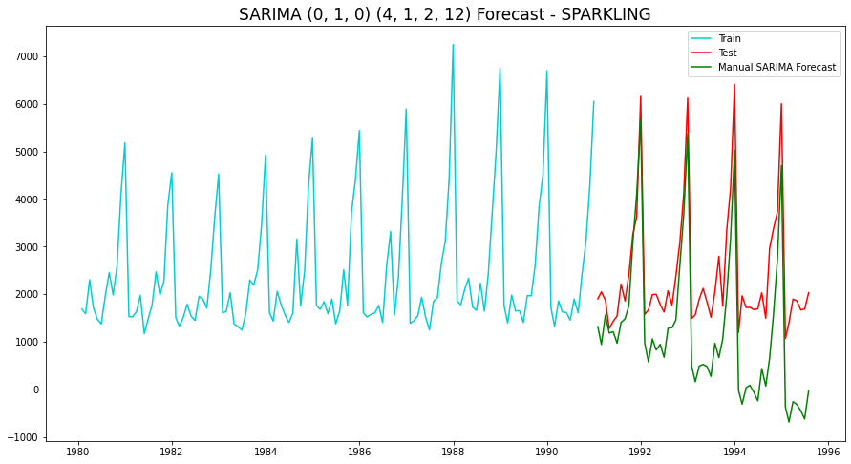
SARIMA (0, 1, 0) (4, 1, 2, 12)– Manual SARIMA

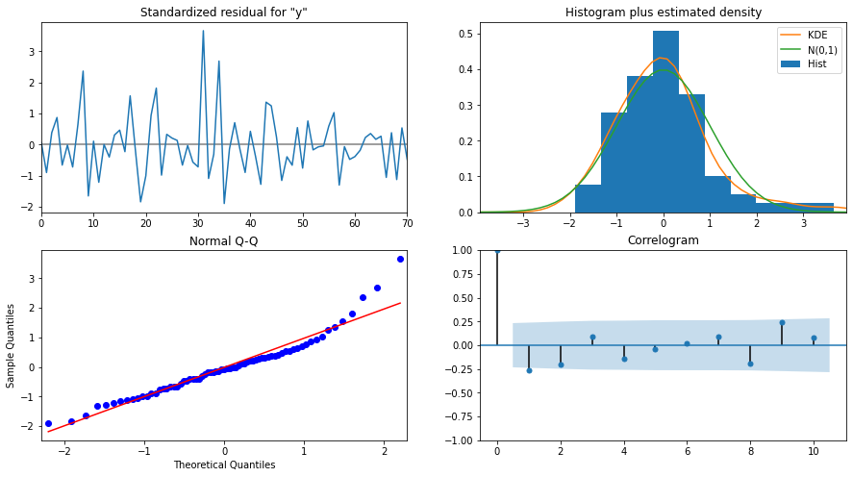

SARIMA (0, 1, 0) (4, 1, 2, 12) - Diagnostic Plot – Sparkling

Data Frame with all the RMSE values for models built:

Model Name | Test RMSE Sparkling
Regression On Time | 1389.135175
Naive Model | 3864.279352
Simple Average Model | 1275.081804
4point Trailing MovingAverage | 1156.589694
6point Trailing MovingAverage | 1283.927428
9point Trailing MovingAverage | 1346.278315
Simple Exponential Smoothing | 1338.004623
Double Exponential Smoothing | 5291.879833
Exponential Smoothing (Additive Seasonality) | 378.626241
Exponential Smoothing (Multi Seasonality) | 403.706228
ARIMA (2, 1, 3) | 1299.98066
ARIMA (2, 1, 2) | 3864.279352
SARIMA (2, 1, 1) (1, 0, 3, 12) | 1000.643795
SARIMA (2, 1, 2) (2, 1, 3, 12) | 1336.560606

Conclusion:

As we can see the above table, the lease RMSE out of all models built is Exponential Smoothing (Additive Seasonality).

Let us now build the model on full data and predict the upcoming 12 months.

Final Model – Exponential Smoothing with additive seasonality

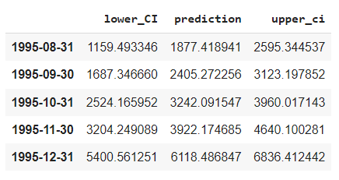

Final Model Forecast: Exponential Smoothing (Additive Seasonality) - Sparkling

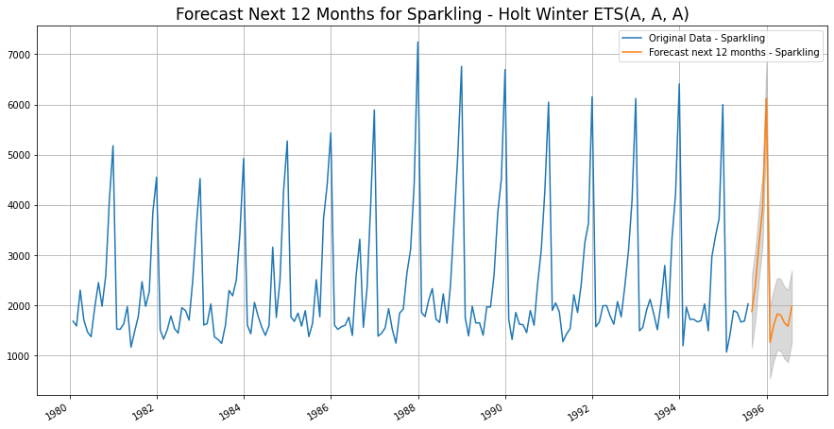
Final Model: Exponential Smoothing (Additive Seasonality) - Sparkling

Sparkling Wine Sales - Comments :
- Sparkling wine sales show no upward or downward trend - this indicates flat sales over the long term range.
- There is also a very high spike in sales seen in the last quarter of every year from October to December.
- The highest peak in sales is seen every year in December
- Dec sales are almost three times that of Sep sales
- Similar to Rose Wine, even in Sparkling sales, an instant crashing slump is seen in the first quarter of every year beginning in January
- This could be due to the after effect or hangover of Holidays

